Third-Party Landing Zone (3PLZ): User Experience Flows, Functional Architecture, and Governance Model

1. Overview
This document expands upon the Third-Party Landing Zone (3PLZ) RFP by introducing detailed user experience flow processes,
supporting platform functionalities, and governance structures required to enable scalable, self-service operation for
up to 1,000 tenant connections. It includes architectural graphics, flow diagrams, and governance frameworks mapped to
industry best practices (NIST, ISO 27001, CIS, and SOC 2).

2. User Experience Flow Summary
Each tenant lifecycle follows five major operational stages: Onboarding, Service Provisioning, Operations, Change
Management, and Offboarding. Each flow enforces Zero-Trust principles and least-privilege access control.
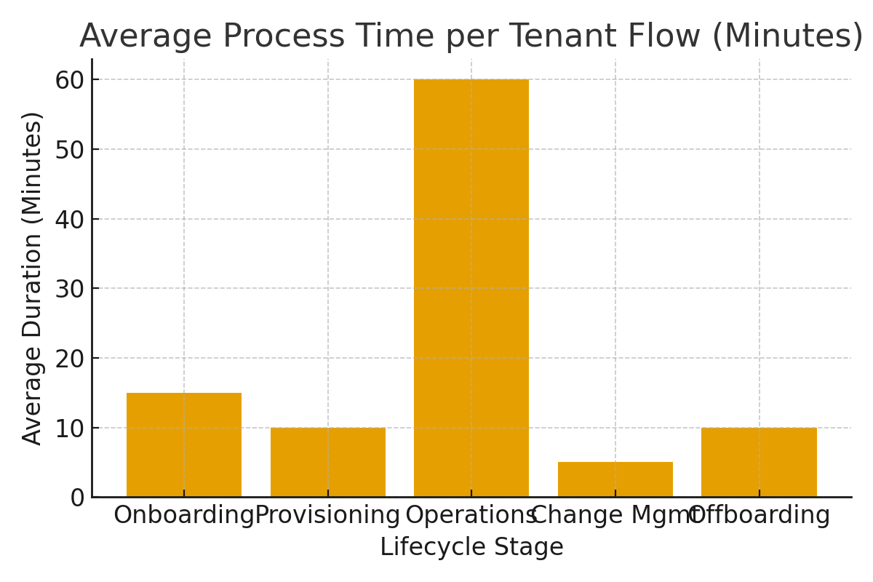

3. Functional Architecture Components
The architecture integrates modular components for connection management, automation, security, and observability.
Each component is built to horizontally scale and isolate per tenant, ensuring consistent performance across
1,000 simultaneous connections.
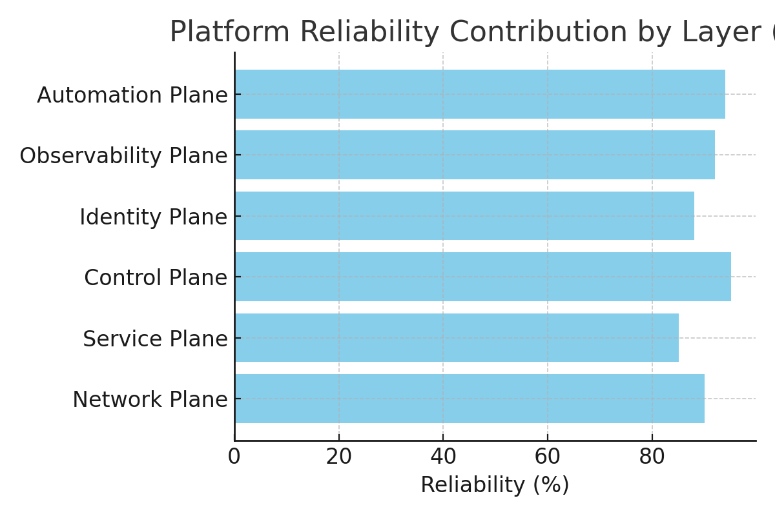

4. Business Governance Model for Self-Service Consumption
To effectively support self-service consumption by application development teams, the 3PLZ solution must include
structured business governance that ensures compliance, accountability, and continuous security posture management.
The following framework defines the governance model across operational, security, and policy domains.

4.1 Governance Structure
Governance must be established as a collaborative operating model involving the following roles:
- **Service Owner:** Defines service templates, monitors SLAs, manages platform budgets.
- **Information Security (Infosec):** Oversees compliance, cert management, and risk audits.
- **DevOps Automation Lead:** Maintains Infrastructure-as-Code pipelines, policy enforcement, and workflow triggers.
- **Application Owner:** Requests and consumes connectivity via self-service portal or API.
- **Compliance Auditor:** Validates control evidence (SOC2, ISO 27001).

4.2 Policy Governance Controls
Policies should align to ISO 27001 Annex A and CIS Controls. Key policies include:
- **Access Control Policy (A.9):** Defines authentication via SSO/MFA and per-service certificate enforcement.
- **Change Management Policy (A.12.1.2):** All changes automated via GitOps pipeline with audit trails.
- **Data Protection Policy (A.13):** Enforces TLS 1.3 and FIPS 140-3 validated cryptography for all flows.
- **Incident Response Policy (A.16):** Defines event triage through automated SIEM alerting and ticket generation.

4.3 Governance Lifecycle
Each self-service tenant follows a governance lifecycle integrated with automated approval and review gates:
1. **Request:** Developer submits connection or service profile request.
2. **Review:** Platform enforces predefined templates and risk checks.
3. **Approval:** System auto-routes for policy owner approval (RBAC driven).
4. **Provision:** Terraform pipelines create isolated tenant environments.
5. **Monitor:** Continuous compliance metrics and usage dashboards feed into monthly reporting.
6. **Renew or Retire:** Expired tenants are renewed or gracefully decommissioned.
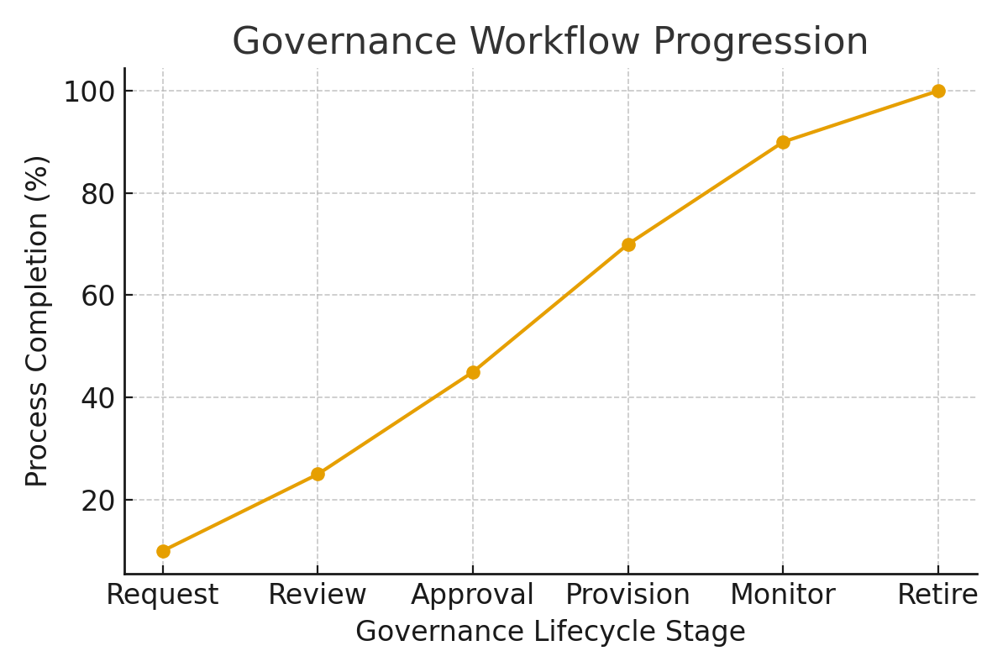

5. Scaling Strategy for 1,000 Tenant Connections
To scale effectively to 1,000 tenant connections, the 3PLZ platform employs a multi-plane architecture with automated
provisioning and container-based workload orchestration. Scaling is achieved through horizontal elasticity, infrastructure
automation, and distributed monitoring. Key technologies include Kubernetes, Anycast IP termination, and a federated
PKI/Vault model for certificate issuance.

6. Summary
A fully operational and self-service Third-Party Landing Zone demands an integrated blend of automation, governance,
and security alignment. By embedding business governance with technical automation, the platform can sustain growth,
reduce operational friction, and maintain compliance with ISO 27001 and NIST Zero Trust standards.

